Bit Rate Video Coding in Wireless Multimedia Application of Low Communication
Wang wenmin¹ | Li shenghui²
^{1,2}China Mobile Online Service Co., Ltd., Zhengzhou 450000, Henan, China
To Cite this Article
Wang wenmin, Li shenghui, “Application of Low Bit Rate Video Coding in Wireless Multimedia Communication”, Journal of Engineering Technology and Sciences, Vol. 01, Issue 01, November 2024, pp.-01-10
_____________________________________________________________________________________________
Abstract: More complex multimedia coding is driven by growing technologies and the increasing need for excellent video for wireless communication. The study focuses on the application in wireless multimedia transmission using low-bit video coding. The procedure depends largely on the loss contour compression. The most important component of this region-based method is to encode and decode low-bit movies streaming through wireless multimedia. The study presents an improved technique for the B-spline, resulting in roughly 40% greater compression compared to the predominantly lossless conditional chain coding method.

Keywords: Multimedia, wireless, B-splines, Video coding, Low bit rate
_____________________________________________________________________________________
- Introduction
The superhighway for wireless communication has offered multimedia access for many individuals globally. Integrated audio, data streams and video communication have developed enormously over the years to encompass integrated devices such as household appliances. Multimedia communication offers a good chance to play a major role in helping individuals who rely on wireless communication, such as mobile subscribers. Currently, some persons have extremely effective mobile communication systems to improve the professional work quality that is to be carried out. Most of the gross domestic products are derived from mobile telecommunications [1]. Wireless communication emphasises the relevance of wireless technologies that make mobile communication possible and enabled.
- Methodology
Compression video. The latest advancements in low-bit video coding and video compression include coding components based largely on segmentation concepts. In this procedure, the picture sequences are broken down into spatio-time, which is either judged to be relevant to the application of choice.

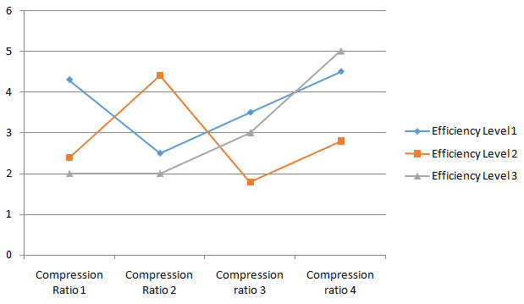
Figure 1: Low Bit-rate Technique Levels of Efficiency

Compression contour. The digital contour may be precisely described as the ordered set of the eight pixels of the object placed on the frontier of the object. In most situations, the contour is rapid and seldom intersects. The methods and approaches to contour coding must be maintained as general as feasible. They should never utilise the specific information of the segmentation techniques employed in the creation of object masks. The eight linked contours may
The number of segments necessary to approximate the specified counter and the links between the subgroups of the samples taken on the original contour. The parameter of the equation referred to as I may be utilised analytically in place the uniform B-spline in the contours supplied by the depreciation of the measurement of average square distance by the approximation and original contours. Table 1 illustrates the B-Spline evaluation for maximum 1 pixel variation on external and inner objects using conditional chain codes. The underlying problem therefore needs the solution of the equation: = [q', and q]-1q'r.... (ii)

Table 1: B-Spline Evaluation for a maximum deviation of 1 Pixel

Objects | Chain Codes which are conditional | Best spline cases(with and without VLC) | Best case for splines(with and without ) | Best spline cases(with and without the VLC)
Block | 1.07 | 0.8/0.56 | 0.62/0.53 | 0.76/0.17
Model Area of Failure | 1.64 | 1.75/1.32 | 1.51/1.76 | 0.19/1.23
Hand | 1.54 | 0.92/0.78 | 0.87/0.73 | 0.77/0.57
Contour | 1.32 | 1.09/0.16 | 0.65/0.56 | 0.67/0.76
Average over 16 objects | 1.50 | 1.05/0.87 | 1.02/0.53 | 1.02/0.67

The q is a matrix of the order m*s containing the spline foundation functions that are assessed at the specified location at m and defined by u values in the approximative curve. The m samples chosen are generally contained on the original contour in the R vector as the control points are on the C vector. The control points should be rounded off to the grid's closest integer. In the low-bit video coding of the wireless multimedia communication the transmission to the decoder takes place. The approximate divide, however, does not need to travel through the original contour points at the end points of the segments. Table 2 shows the block, contour, model area fault and hand objects comparison over a single pixel versus double pixel variation.

III. Results
The compressed control points are subsequently inferred in decoded algorithmic forms evaluated in several regular and irregular artificial tested objects, where Object-based Codec produces model failure regions. The outcome is a set of resilient crucial algorithm parameters that show that suggested iterative optimisation is thus necessary for contour segment numbers [10]. Average BPCP of 0.82 for specified parameters was achieved for deviating maximums with one pixel within and two pixels outside the objects. The histogram showing differences of control points is shown in Figure 3 below.

Further data breakdown has shown that a 10 percent stretch factor in bit rates led to various parameters and varied the order in which iterative stages are tuned. A compression of 20 percent is therefore provided using entropy-coded control points. When maximum permissible inside deviations are increased by two pixels, the average decreases to 0.70BPCP. Alternatively, the average difference with maximum 1 pixel differences is 0.88BPCP[6].

IV. Conclusion
The objective of this project was to investigate the applicability of low-bit video coding in wireless multimedia communication. During the research, we discussed the video compression techniques and all the procedures involved. We have explicitly explained the processes of video and contour compression and examined using iterative approximation the polynomial approximation technique for B-Splines contour. In concluding, low-bit video encoding is a very lucrative sector in multimedia communication, with applications that expand dramatically over time each day.

References
- Canterle, D. R., da Silveira, T. L., Bayer, F. M., & Cintra, R. J. (2020). A Multiparametric Class of Low-complexity Transforms for Image and Video Coding. Signal Processing, 176, 107685.
- Chen, F., Zhang, J., Zheng, M., Wu, J., & Ling, N. (2021). Long-Term Rate Control for Concurrent Multipath Real-Time Video Transmission in Heterogeneous Wireless Networks. Journal of Visual Communication and Image Representation, 102999.
- Esakki, G., Panayides, A., Teeparthi, S., &Pattichis, M. (2020, August). A comparative performance evaluation of VP9, x265, SVT-AV1, VVC codecs are leveraging the VMAF perceptual quality metric. In Applications of Digital Image Processing XLIII (Vol. 11510, p. 1151010). International Society for Optics and Photonics.
- Khursheed, S., Badruddin, N., Jyoti, V., & Hashmi, M. A. Fast Side Information Generation for High-Resolution Videos Distributed Video Coding Applications.

